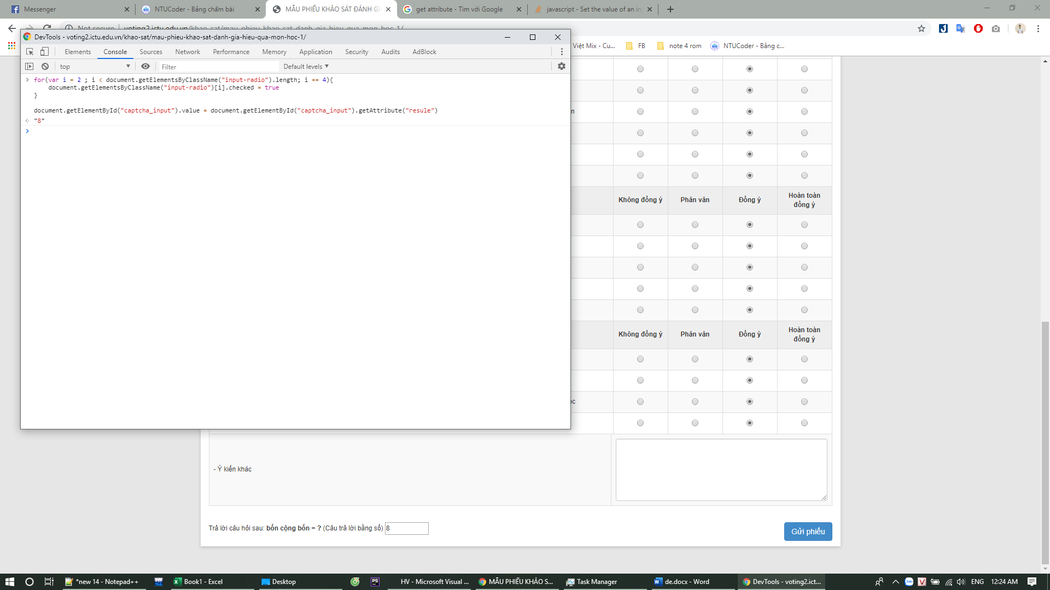

for(var i = 2 ; i < document.getElementsByClassName("input-radio").length; i += 4){

document.getElementsByClassName("input-radio")[i].checked = true

}

document.getElementById("captcha_input").value = document.getElementById("captcha_input").getAttribute("resule")